YPC INTERNATIONAL COLLEGE



BSc (Hons) Multimedia Computing

Software Implementation and Testing

(Test plan and user guide)

Coursework 2

Problem Solving in Multimedia Computing

4118COMP

Miss Aniza

BMC1904254



897147

Contents

Test Plan 3

User Guide 9

Index page 9

Home Page 10

Category pages 12

Nightlife page 14

References 15

# Test Plan

|  |  |  |  |
| --- | --- | --- | --- |
| **Case** | **Reason** | **Result / Expected Result** | **Pass / Fail** |
| Button: Leave this page | Close the website to spare visitors their time from scrolling through irrelevant recommendations | Exit website, end all program | Pass |
| Button: I want to Proceed | Proceed to Home Page if user validates their age to ensure that visitor entering the pages are of relevant age group | Open Home page  Exit validation page | Pass |
| Transparency | Hover mouse over certain image or area of webpage to increase transparency and see-through the background | Without hover:  On hover: | Pass |
| Responsive background image | As user scroll down the home page, different parts of the background image get revealed while texts position remain unchanged | Before scroll:After scroll: | Pass |
| Slideshow button: prev | Call the function move(n) and assign value -1 to “n” to decrement the slideIndex number  show the previous image via function show(n) | n=-1 | Pass |
| Slideshow button: next | Call the function move(n) and assign value +1 to “n” to increment the slideIndex number  show the next image via function show(n) | n=+1 | Pass |
| n>x.length | If “n” has been incremented to exceed the number of images in the slideshow, begin from the first image | slideIndex=1 | Pass |
| n<x.length | If “n” has yet to exceed the number of images in the slideshow, show the image with the index number “n” | slideIndex=x.length | Pass |
| Internal links | To link user from Home page to the categories page such as Shopping, Eating Out, Entertainment, Historical sites, Tourist Attraction, and night life and navigate users from the said page back to home page | Home page to Shopping page | Pass |
| Home page to Eating Out page | Pass |
| Home page to Entertainment page | Pass |
| Home page to Tourist Attraction page | Pass |
| Home page to Historical Site page | Pass |
| Home Page to Night Life page | Pass |
| Shopping page back to Home page | Pass |
| Eating out page back to Home page | Pass |
| Entertainment page back to Home page | Pass |
| Tourist Attraction page back to Home page | Pass |
| Historical site page back to Home page | Pass |
| Night Life page back to Home page | Pass |
| External links | Navigate within different websites. To direct user to the official website of different places so they can read in further details or make bookings | The Art School restaurant link | Pass |
| Marray Liverpool link | Pass |
| Bacaro link | Pass |
| Panoramic34 link | Pass |
| Roski Restaurant link | Pass |
| Elif Turkish BBQ Restaurant link | Pass |
| Your Thai Café link | Pass |
| Etsu link | Pass |
| Yukti Indian Street Fusion link | Pass |
| The Egg Café link | Pass |
| Hyperlinks | To help user navigate within the same page via browsing by category | Shopping page (7 hyperlinks) | 7/7 Pass |
| Eating Out page (12 hyperlinks) | 12/12 Pass |
| Historical Site page (6 hyperlinks) | 6/6 Pass |
| Entertainment page (6 hyperlinks) | 6/6 Pass |
| Tourist Attraction page (7 hyperlinks) | 7/7 Pass |
| Dynamic Hyperlinks | To change the content of a page based on the link user click by showing relevant contents and hiding everything else | Show Live Music Bar | Pass |
| Show Bar | Pass |
| Show Cocktail bar | Pass |
| Show Pub | Pass |
| Show Night Club | Pass |
| Responsive Window | Change side pane to top navigation when window size reach 50% | Side pane align at top | Fail |
| Load Index page (Age verification) | Increase performance and loading speed by reducing file size (image resolution) in effort to minimize lagging | Load within 3 seconds | Pass |
| Load Home page | Pass |
| Load Shopping page | Pass |
| Load Eating Out page | Pass |
| Load Entertainment page | Pass |
| Load Historical site page | Pass |
| Load Tourist Attraction page | Pass |
| Load Night Life page | Pass |

# User Guide

## Index page

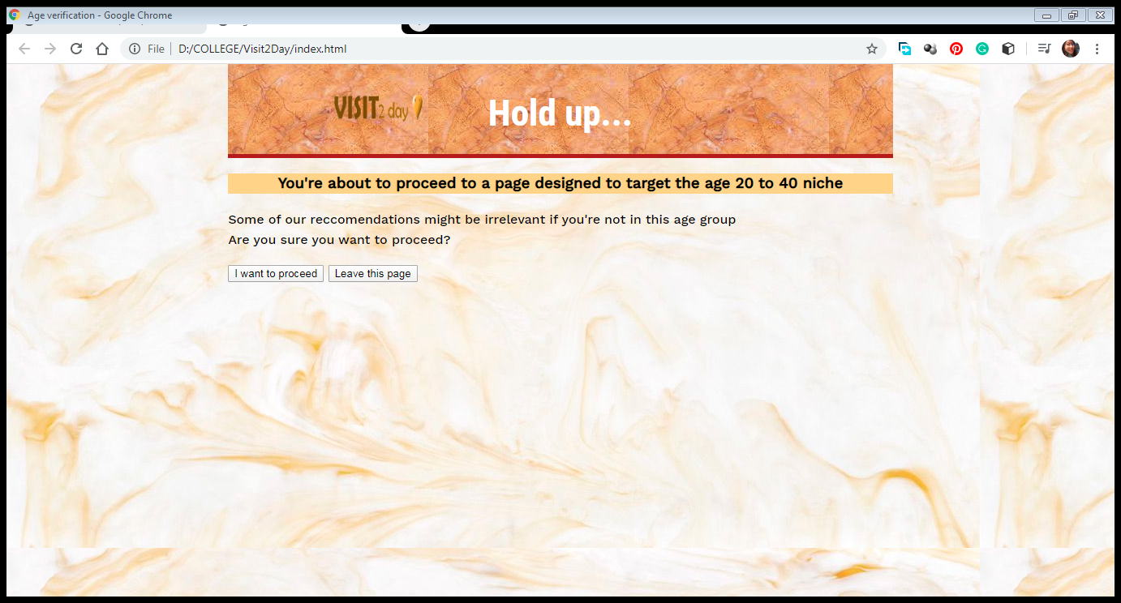

The default page that will be displayed each time the website is loaded is the index.html, which will get age verification from user via a small message.

## Home Page

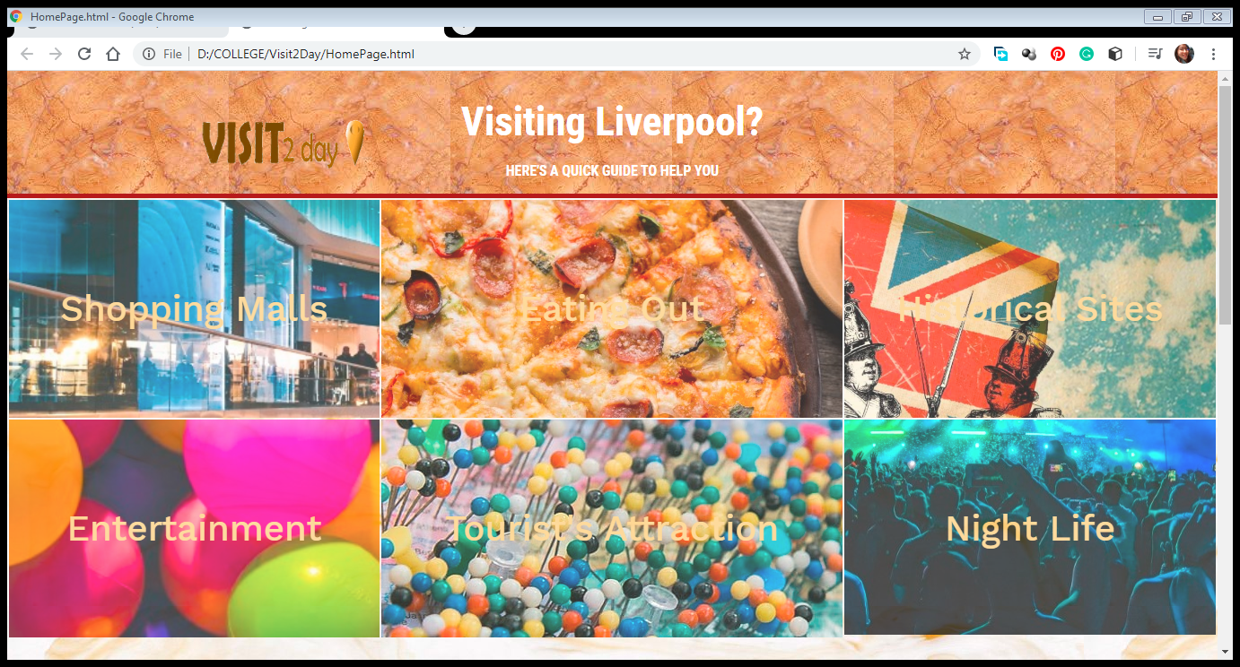

User will be directed to the home page upon clicking the proceed button. The website will exit if they click otherwise. The interactive layers proposed in the proposal were most prominent in the home page where by user can reveal different parts of an image by scrolling down the website.

Before vs after scroll:





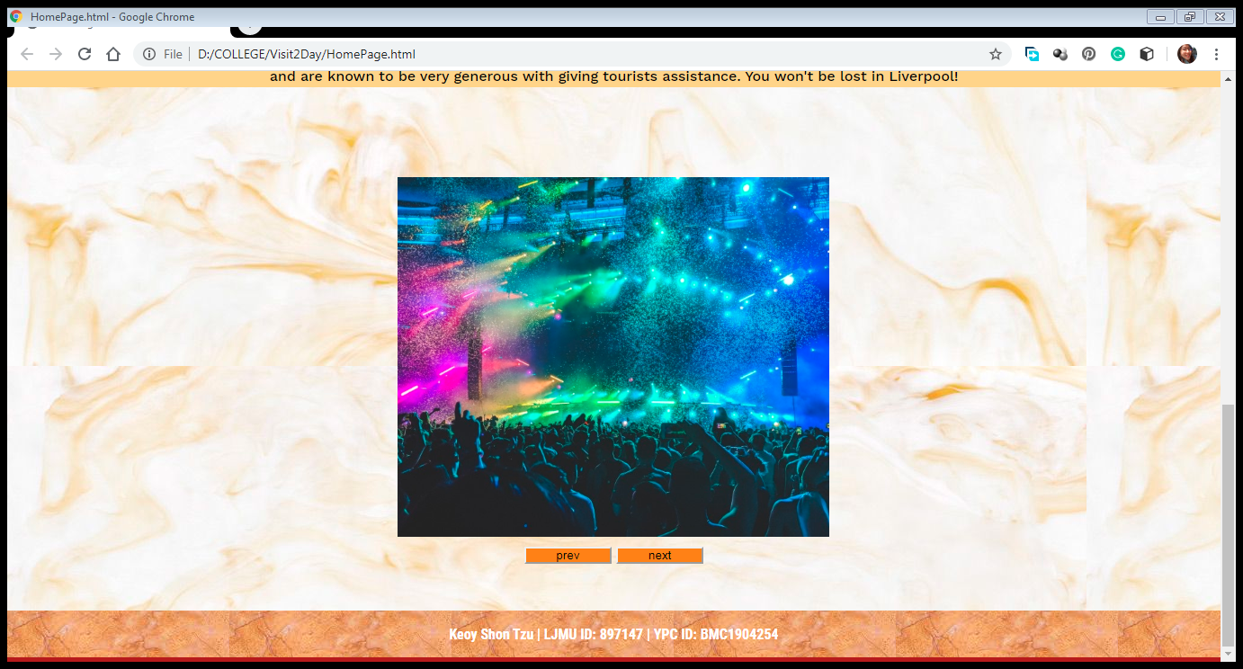

At the bottom of the home page there’s a slide show to briefly show users everything that will be recommended in the website. The home page also features full-screen background image as proposed in the proposal.

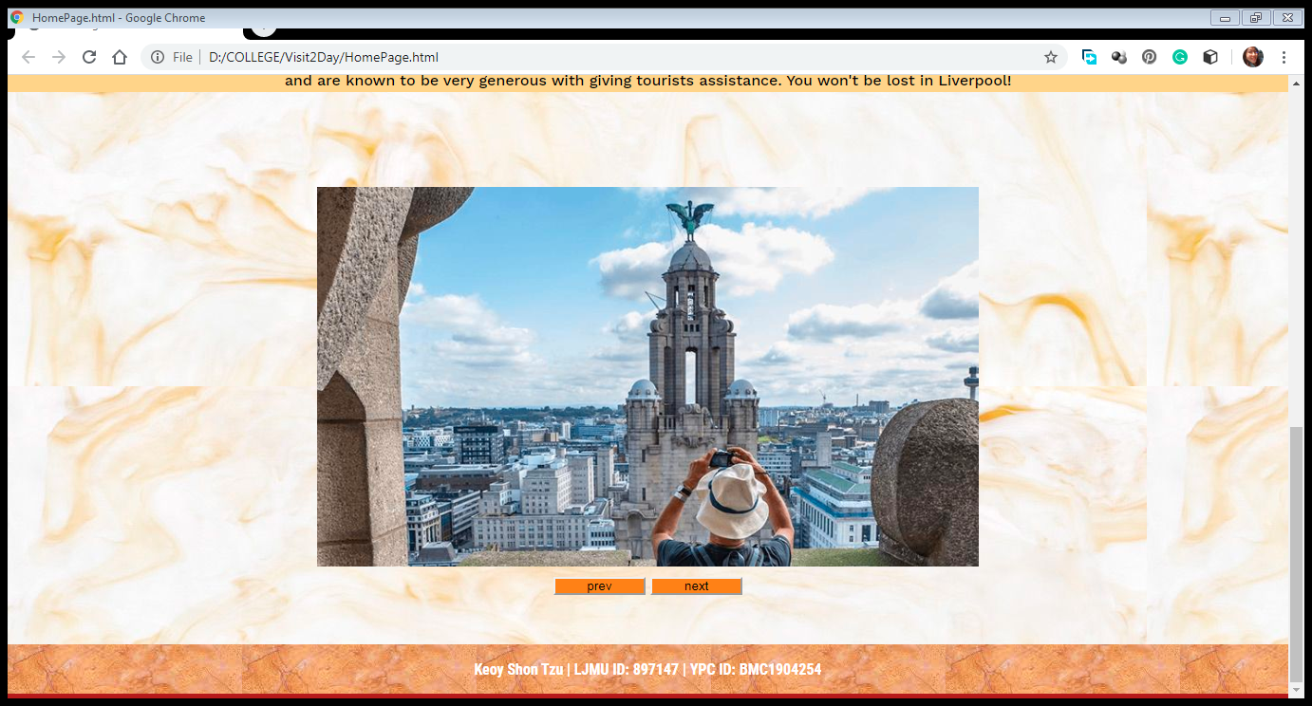

## Category pages

|  |  |
| --- | --- |
| Shopping Malls - Google Chrome | The categories pages follow a uniform design; there’s a side pane to navigate or jump within the same page instead of having to scroll. There’s a header and a short note followed by a two-column body. There are slight changes from the proposed design where two images lay side-by-side and their description went below the images. |

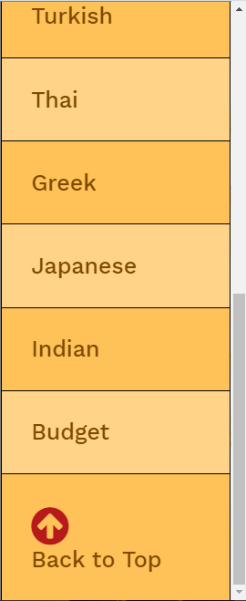 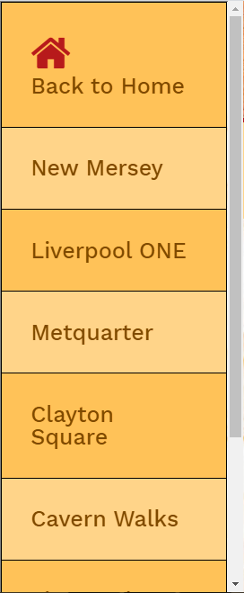 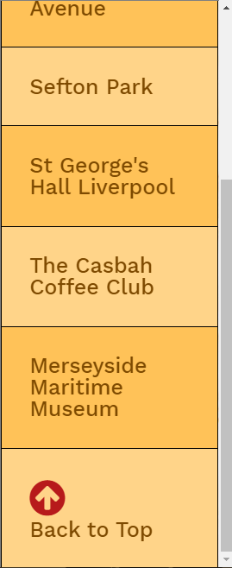 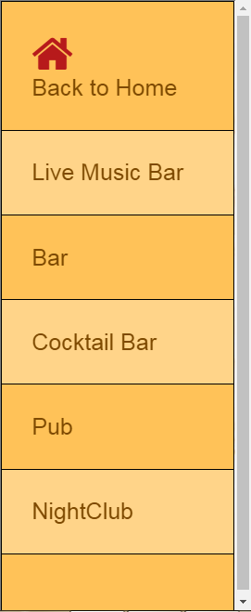

New features were added such as a button to navigate back to home page and another to jump back to the top of the page so there is no need to scroll. The only page without this feature is the night life page because instead of navigating within the pages, the side pane upon click will hide and show different information. Because of this, there is no “top” of a page.

The opacity feature as proposed in the proposal can also be seen by hovering on the side pane. The marble background of the body can be seen through the side pane.

 

Figure 0.1: no hover (background: orange) Figure 0.2: hover (background: see-through)

## Nightlife page

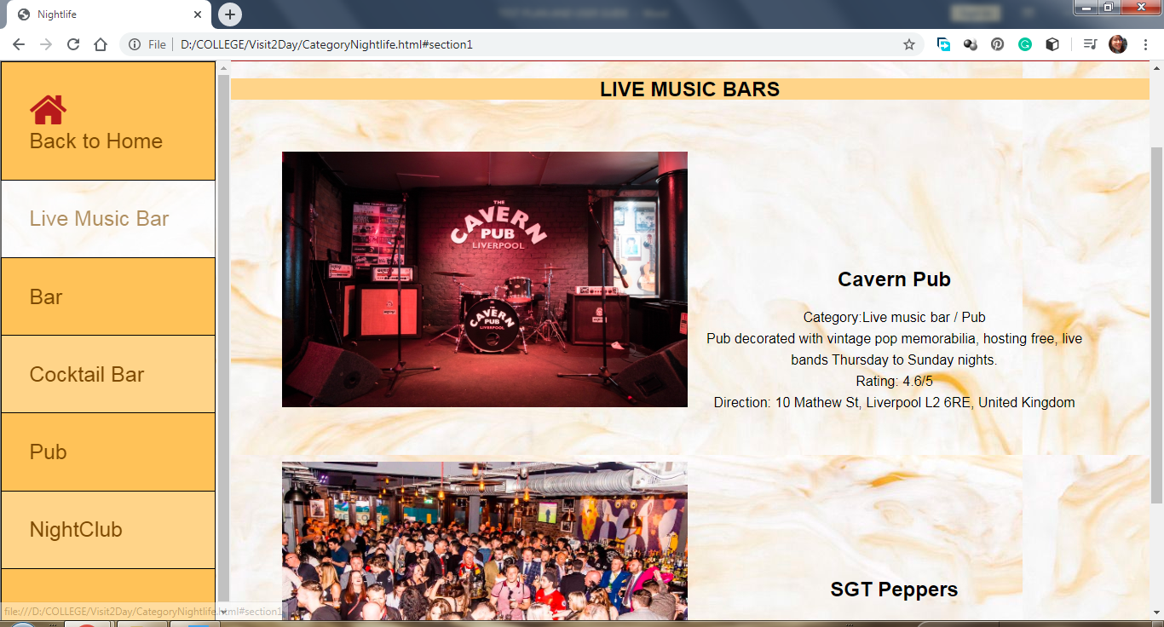

The content of the body in the night life page changes depending on what’s selected from the side pane. Other details will be “hidden”.

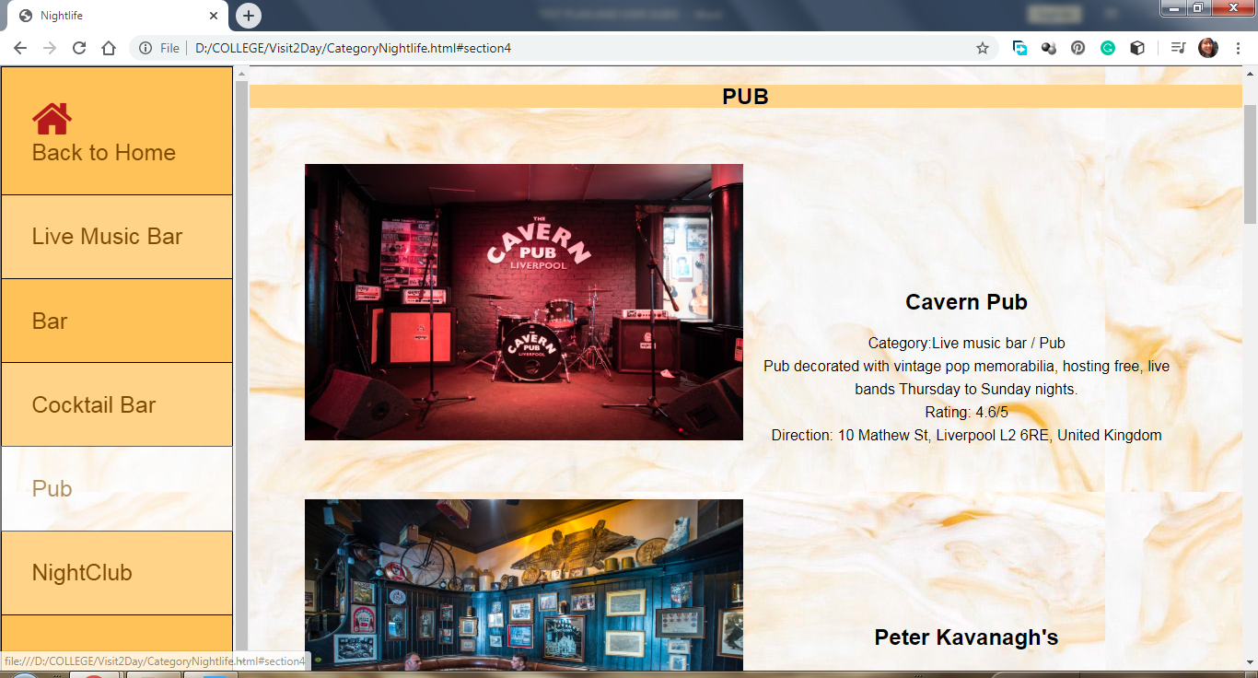

# References

Anon., 2015. *TICK TOCK UNLOCK AGREES KINGS HOUSE DEAL.* [Online]   
Available at: https://www.insidermedia.com/news/yorkshire/136884-  
[Accessed 28 March 2020].

Anon., n.d. *Insider Media.* [Online]   
Available at: insidermedia.com  
[Accessed 30 March 2020].

Anon., n.d. *Liverpool Echo.* [Online]   
Available at: https://www.liverpoolecho.co.uk/  
[Accessed March 2020].

Anon., n.d. *Santa Chupitos - Visit Liverpool.* [Online]   
Available at: https://www.visitliverpool.com/food-and-drink/santa-chupitos-p428781  
[Accessed 28 March 2020].

Anon., n.d. *The Best Liverpool & Manchester Activities For Stag Hen And Birthday Parties.* [Online]   
Available at: https://www.merseygames.co.uk/  
[Accessed 28 March 2020].

Anon., n.d. *Ultimate Indoor Paintball - Liverpool City Centre.* [Online]   
Available at: Paintballingpaintballingliverpool.co.uk  
[Accessed 28 March 2020].

Anon., n.d. *Visit Liverpool.* [Online]   
Available at: visitliverpool.com  
[Accessed 28 March 2020].

Anon., n.d. *WELCOME TO A WORLD OF UNLIMITED EXCITEMENT.* [Online]   
Available at: https://escapehunt.com/  
[Accessed 28 March 2020].

Bar magazine, 2020. *Bar magazine.* [Online]   
Available at: https://barmagazine.co.uk/  
[Accessed 28 March 2020].

Burke, J., 2014. *Top 10 bars and clubs in Liverpool.* [Online]   
Available at: https://www.theguardian.com/travel/2014/mar/28/top-10-bars-clubs-nightlife-liverpool  
[Accessed 17 March 2020].

Chinchure, A., n.d. *group of people in front of stage.* [Online]   
Available at: Unsplash.com  
[Accessed 17 March 2020].

Joralemon, G., n.d. *high angle photo of assorted-color plastic balls.* [Online]   
Available at: Unsplash.com  
[Accessed 17 March 2020].

Kevern, R., 2019. *The 10 best places to go shopping in Liverpool.* [Online]   
Available at: https://www.timeout.com/liverpool/things-to-do/best-places-to-go-shopping-in-liverpool  
[Accessed 17 March 2020].

Kevern, R. W. & Rachel, 2019. *The 23 best restaurants in Liverpool.* [Online]   
Available at: https://www.timeout.com/liverpool/restaurants/best-restaurants-in-liverpool  
[Accessed 17 mARCH 2020].

Kirwin, E., 2019. *Liverpool's top 30 restaurants according to TripAdvisor.* [Online]   
Available at: https://www.liverpoolecho.co.uk/whats-on/food-drink-news/liverpools-top-30-restaurants-according-9113788  
[Accessed 17 mARCH 2020].

LaReine, S., n.d. *A Guide to Shopping in Liverpool.* [Online]   
Available at: https://all.accor.com/gb/united-kingdom/magazine/follow-me/a-guide-to-shopping-in-liverpool-fa9dc.shtml  
[Accessed 17 March 2020].

Ramsthaler, B., n.d. *Casbah Coffee Club Liverpool.* [Online]   
Available at: Subtouring.com  
[Accessed 28 March 2020].

Rennie, S., 2019. *Heebie Jeebies is the club everyone in Liverpool loves to hate and hates to love.* [Online]   
Available at: https://thetab.com/uk/newcastle/2019/11/18/heebie-jeebies-is-the-club-everyone-in-liverpool-loves-to-hate-and-hates-to-love-46568  
[Accessed 28 March 2020].

Tucker, T., n.d. *top view photo of pepperoni pizza beside brown cup filled with yellow liquid and ice cubes.* [Online]   
Available at: Unsplash.com  
[Accessed 17 March 2020].

Wright, J., 2016. *99 pictures of Liverpool Bars and Clubs.* [Online]   
Available at: https://www.liverpoolecho.co.uk/whats-on/music-nightlife-news/99-pictures-liverpools-bars-clubs-11204616  
[Accessed 28 March 2020].